Kinetic limitations on equilibrium for a model aerosol composition.

*A. Murray Booth, David O. Topping, Illona Riipinen, Carl J. Percival*

**Introduction**

A significant fraction of atmospheric aerosol particles are comprised of organic material (20-90% of particle mass) (Jimenez et al., 2009), containing potentially thousands to hundreds of thousands of compounds with largely uncertain physic-chemical properties. Traditionally, two assumptions have been made about the physical state in order to calculate aerosol growth and lifetime; 1) the aerosol phase is a well-mixed non-viscous liquid; 2) the aerosol phase instantaneously equilibrates with the gas phase constituents. It is becoming increasingly evident that aerosols exist as metastable amorphous states, rather than simple liquid/solid mixtures (Virtanen et al., 2010). Indeed, empirical evidence suggests that particles can form glass like substances (Zobrist et al., 2008). This has several important implications for climatic and health effects of organic aerosol: The low diffusivity of water within an aerosol particle might influence its ability to grow in a humid environment and thus effect the direct and indirect climatic effects (Tong et al., 2011); the low diffusivity of individual organic molecules in solid/amorphous organic mixtures could directly affect their mass transfer, and thus the loading and composition whilst ice nucleation has been observed to be suppressed (Murray et al., 2008). The large potential impact on gas-to-particle partitioning combined with our relatively poor understanding of viscous behaviour in aerosol particle necessitates the fundamental study of well defined model systems of atmospheric relevance, in order to determine the magnitude of these effects.

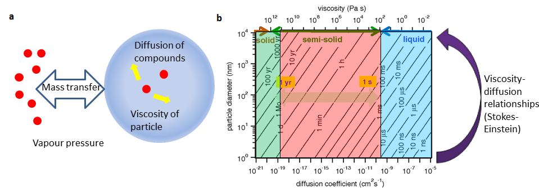

Figure 1 Viscosity, diffusion and aerosol particles. a molecules (red) within an aerosol particle (blue) reaching equilibrium with the gas phase by mass transfer from the condensed phase and diffusion within the particle. b The relationships for particle size, diffusion coefficient and characteristic equilibrium time, divided into different viscosity regimes; solid (green) semi solid (peach) and liquid (blue) from Shiraiwa et al., (2011).

Figure 1a depicts an aerosol particle, the particle changes size and composition by mass transfer of its constituent molecules (red) between the condensed phase and the gas phase according to the equilibrium vapour pressure, activity coefficient and accommodation coefficient. In order to do this however, molecules from the core of the aerosol particle must be free to diffuse from the interior to the surface, any limitation on this diffusion will impact the time it takes to reach equilibrium and hence the size, composition, and water content of the aerosol particle. Figure 1b (modified from Shiraiwa et al, 2011) illustrates the impact of different diffusion coefficients, D (in this case water) as a function of aerosol particle diameter. The graph shows diagonal lines of constant equilibrium times, for example water in both a 10 nm particle with a D of 10-15 cm2s-1 and a 10 µm particle with a D of 10-9 cm2s-1 will take about 1 min to reach equilibrium with its surroundings. Viscosity,η and diffusion, D are intimately linked, and there are several proposed models for the relationship between them, the most popular being the Stokes-Einstein equation:

$$D=\frac{kT}{6πηr}$$

where r is the hydrodynamic radius of the diffusant. The graph displays the viscosity required for a given diffusion coefficient assuming the Stokes-Einstein relation is valid. The graph is divided (according to the viscosity) into coloured regions which indicate when the particle is liquid, semi-solid and solid to give an easier understanding of the levels of viscosity encompassed. Conceptually the time scales indicate whether it is kinetic (viscosity/diffusion) or thermodynamic (vapour pressure/ activity coefficients) that determine the size and composition of an aerosol.

**Results**

In order to understand the potential impacts of kinetic limitations viscosity measurements of bulk proxies for secondary organic aerosol (SOA) were studied which can then be related to diffusion coefficients and equilibrium times. Bulk measurements allow us to probe specific material properties of aerosol forming material without introducing further complications and it allows the utilisation of techniques which have been refined from other fields. They also give us a well constrained system to test property estimation methods with. The model system chosen is an equimolar mixture of the C3-C10 & C12 dicarboxylic acids as used in Cappa et al., (2008) which can be considered as representative of dry atmospheric organic aerosols. Dicarboxylics are ubiquitous in the atmosphere (Hallquist et al., 2009) and have been identified in marine, urban and arctic environments, this makes them ideal compounds for bulk studies of aerosol properties. The samples were also prepared with increasing mole fractions of water to understand how humidity could influence viscosity. To test the Stokes-Einstein equation, the Diffusion coefficient for water was measured in different viscosity media using Taylor Dispersion. This was carried out using an Agilent 1260 HPLC with a refractive index detector. Dynamic viscosity measurements were made using a commercial DHR-01 rheometer from TA Instruments. It was operated in oscillatory mode with a displacement of 10e-3 radians to remain within the linear viscoelastic region and at a frequency of 1Hz. The temperature was controlled using a peltier element, the geometry was an 8 mm diameter parallel plate (see supplementary details for further information).

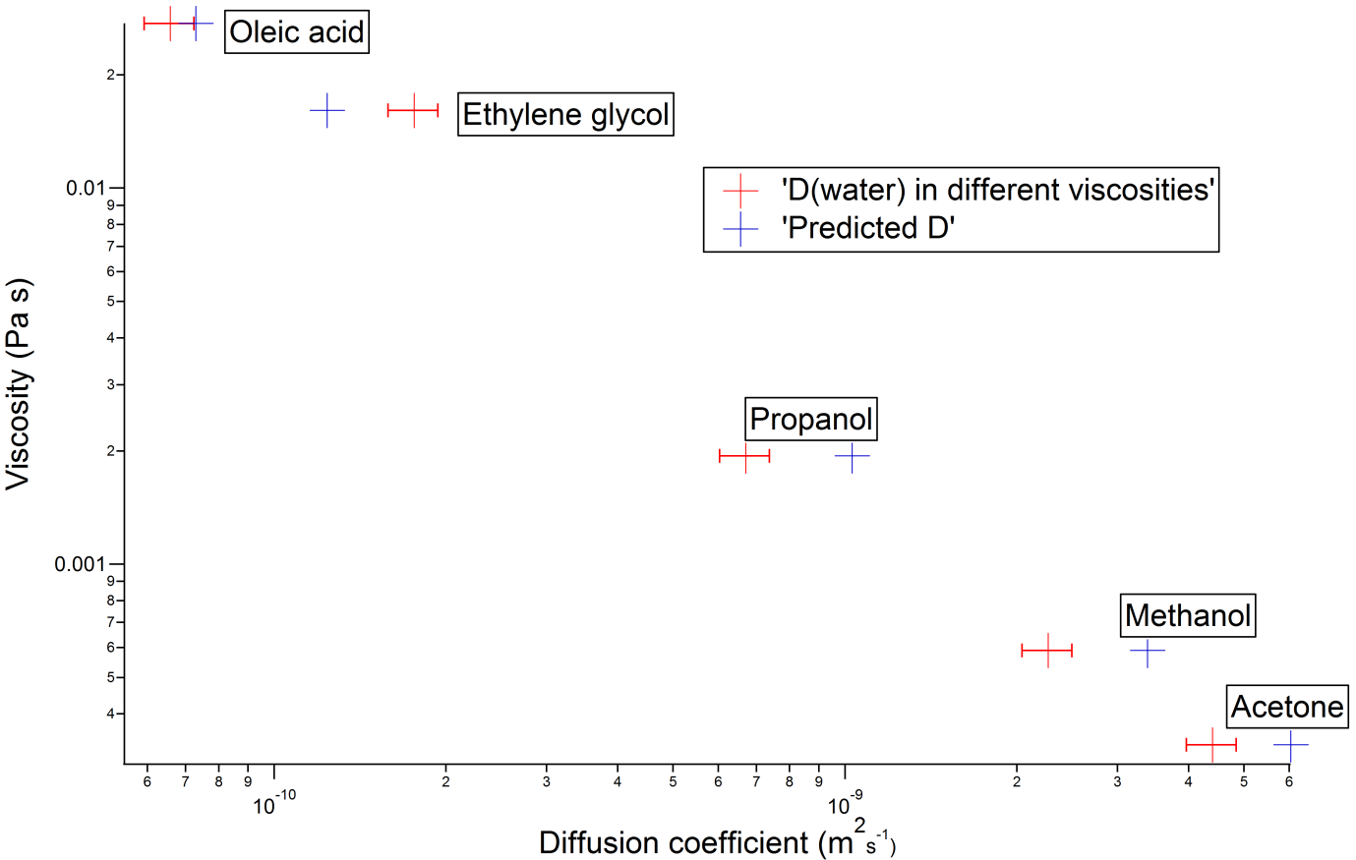

Figure Diffusion coefficients of water in different media.

Figure 2 shows diffusion coefficients for water measured in different viscosity media (Oleic acid, ethylene glycol, propanol and acetone) using Taylor dispersion. Also shown are estimates of the diffusion coefficient using the viscosities of the solvents and a hydrodynamic radius of water derived from water self-diffusion values (Holz et al 2000). Over the range of viscosities measured here (0.027 Pa s for oleic acid to 0.0004 Pa s for acetone) the Stokes-Einstein equation predicts diffusion coefficients to within less than ±50% of the measured value with no systematic bias. This confirms the Stokes-Einstein equation may be used simply relate these viscosity measurements to diffusion coefficients.

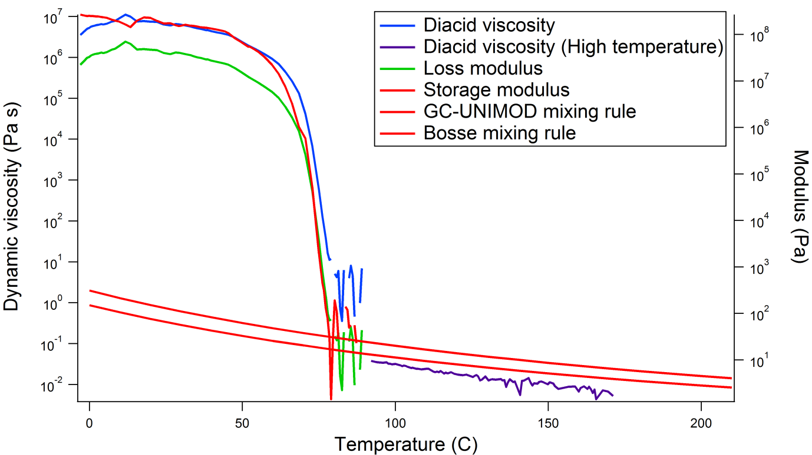

Figure Dynamic viscoisty, loss modulus, and elastic modulus as a function of temperature for dry diacid mix.

Figure 3 shows the change in dynamic viscosity as a function of temperature for the dry diacid mix. It has a viscosity of around 6ˣ106 Pa s at room temperature, which from fig 1b corresponds to a diffusion coefficient of ~10-14 cm2s-1. Depending on particle size, the impact on equilibrium times will be extremely important. For a 10 nm particle, an equilibrium time of ~1 s is not significant, but for PM2.5 the equilibrium time is several days, and for PM10 it is more than a month, longer than the atmospheric lifetime of most tropospheric aerosols.

Upon heating the bulk diacid mix shows a rapid decrease in viscosity between 60 and 80 C which corresponds with a very broad peak in differential scanning caloritmery (DSC) thermograms (see supplementary data). Shown on figure 3 are the crossover in the elastic and loss modulus (G’ and G’’) which are the in phase and out of phase response to the rheometer driving force. The crossover indicates a phase transition showing solid-like properties are beginning to dominate over liquid-like. Mutual melting point depression means the diacid mixture does not solidify at the same temperatures the individual acids do (80 C for the mix compared to 103 C for azealic acid and 184 C for succinic acid). The bulk mix can be supercooled by 20-30 C before the phase change occurs and experiments by Cappa et al (2008) show that aerosols generated from it behave as (non-ideal) liquids over the timescale of a lab experiment (at least a few hours). IR spectra show no chemical change and power x-ray diffraction of the solid phase show it to be amorphous. Upon rapid cooling, many liquid compounds can undergo a non-equilibrium phase transition to solid non-crystalline state known as a glass (far left on fig 1b). At cooling rates likely to be encountered in the atmosphere (i.e. ~5˚C min‑1 for a particle in strong convection updraft of 10 ms-1 and an adiabatic lapse rate of 7˚C km-1) there was no evidence of any glass formation for this mixture from either DSC where glass transitions appear as step changes in the heat capacity or from viscosity measurements where they appear as step changes in G’ and a peak in tan δ, the phase angle between the rheometer driving force and response (see supplementary materials). The lack of regular structure or glass behaviour suggested that the solid phase may be gel-like, with irregular hydrogen bond linkages from the ends of the diacids making it so viscous. The DSC thermograms also show an additional peak around 20 C which does not have any corresponding rheological change.

Property prediction methods are essential when dealing with the large number of compounds suspected to exist in SOA, more than ~10000 (Goldstein and Galbally, 2007). Well constrained systems such as the diacid mix allow us to validate these methods on molecules and functional groups relevant to atmospheric science which are often quite different to those used to train such group contribution methods. Here we use a pure component viscosity estimation method based on the group contribution method of Nannoolal (2004) which has previously been fruitful in estimation vapour pressures of compounds in SOA (Booth et al 2011). This is combined with mixing rules from GC-UNIMOD (Hsu et al., 2000) and Bosse (2005) (see supplementary information). The 298.15 K prediction of 0.74 Pa s for GC-UNIMOD and 0.34 Pa s for Bosse are approximately 7 orders of magnitude too low (see figure 3) for the diacid mix. Further measurements of the viscosity at higher temperatures using a different plate geometry allow us to extrapolate the liquid state viscosity down to room temperature. This shows the estimation method is far closer to the measured value if the particle is in a supercooled liquid state, 0.34 Pa s for Bosse compared with an extrapolated measured value of 0.17 Pa s. It is the failure to predict the state correctly which causes such a wide discrepancy.

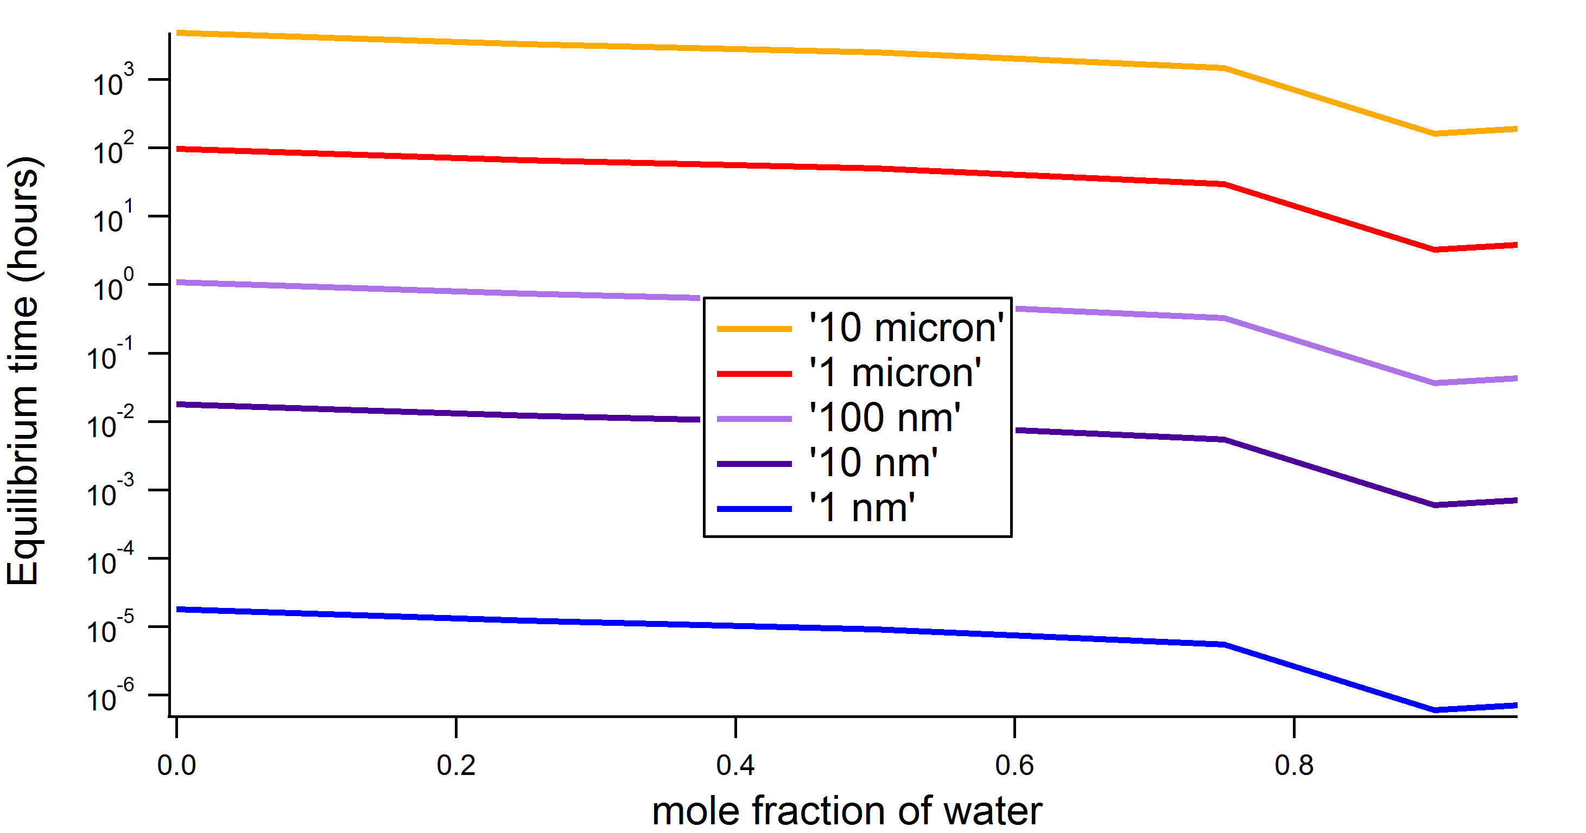

Figure 4. The time taken to reach equilibrium for particles of different sizes and increasing water mole fractions.

Figure 4 shows the characteristic equilibrium time for different sized aerosol particles at increasing water mole fraction at 25 C. Up to mole factions of 0.8, the viscosity does not drop below 2 ˣ106 Pa s which is still in the range for kinetic hinderance. Only once the water content is at >0.9 mole fraction does the viscosity start to decrease significantly. Times are significant for the very largest particles (10µm) varying from 200 days to just over a week for 0.97 moles of water, whereas below 10 nm, the timescales are too fast to matter. For the viscosities displayed by this mixture, the equilibrium timescales cover a huge range, from small enough to not matter in a single instrument to large enough to dwarf the atmospheric lifetime. The impact of equilibrium time is highly dependent on the context, in a lab experiment an equilibrium time of minutes or even seconds may be significant. For work with smog and aerosol chambers timescales of hours may be important, this would encompass any particles greater than 0.1µm.

**Modelling sensitivities or impacts**

**Conclusion**

This is the first bulk rheological study of a representative complex SOA mixture. It shows that at room temperature the representative diacid mix is a solid with a viscosity high enough to prevent the particles reaching equilibrium and can hence dominate the thermodynamic effects of gas-to-particle partitioning. X-ray diffraction shows it is non-crystalline and DSC does not show a glass transition over an atmospherically relevant temperature range and cooling rate this leads us to propose a gel-like amorphous solid as the most likely state. This shows that kinetic hinderance can be important even if the mixture does not form a glass.

Nannoolal pure component viscosity estimation methods combined with GC-UNIMOD and Bosse mixing rules do not capture the extremely high viscosity of the room temperature mix. Results from other workers tell us that aerosols formed from the mix can be supercooled to room temperature and may remain so for several hours. High temperature viscosity measurements and extrapolation to room temperature show us the estimation method is very good at predicting the supercooled state viscosity.

**Bosse** PhD thesis, Technical University of Kaiserslautern, 2005

**Jimenez** et al., *Science*, 326, 1525-1529, 2009.

**Virtanen** et al., *Nature*, 467,824-827, 2010.

**Zobrist** et al., *PCCP,* 13, 3514-3526, 2011.

**Tong** et al., *Atmos. Chem. Phys.,* 11, 4739-4754, 2011.

**Murray** et al., *Atmos. Chem. Phys.,* 8, 5423-5433, 2008.

**Shiraiwa** et al., *PNAS.,* 108,11003-11008, 2011

**Cappa** *PNAS,* 105, 18687-18691, 2008

**Hsu** et al., *Fluid Phase Equi.*, 173, 1-21, 2000.

**Hallquist,** et al**,** *Atmos. Chem. Phys*., 9, 5155-5236, 2009.

**Goldstein, and Galbally,** *Environ. Sci. Tech*., 41, 1514-1521, 2007.

**Booth,** et al., *Atmos. Chem. Phys.,* 11, 655-665, doi:10.5194/acp-11-655-2011, 2011.

**Holz** et al., *PCCP*, 2, 4740-4742, 2000.